**GROUP L**

Breytenbach, CR (Christopher) Mr

Fadda, AT (Arrigo) Mr

Parves, J (Jesse) Mr

**Petrarolo, VM (Venanzio) Mr**

Steenkamp, B (Brandon) Mr

**CJJ 310 COMMUNICATION 310**

**ASSIGNMENT 8**

**CHARACTERISATION OF A CONTROL VALVE**

**14 May 2017**

Characterisation of a control valve

# Synopsis

A control valve had no specifications and was unable to be used. It was required that the control valve should be characterised so that it can be implemented correctly. An experiment was set up for this to be achieved.

For the characterisation experiment, a tank of liquid water was placed above the control valve. The liquid water was allowed to flow through the control valve while the control valve is set to different fractional valve openings. Five different fractional openings were used; 0.1, 0.4, 0.5, 0.6, and 0.7. The flow of the liquid water through the control valve allowed for the analysis of the flow rate at each fractional opening.

The varying flow rates were plotted against the square-root of the change in pressure across the control valve divided by the specific gravity of liquid water. The gradient of each fractional opening is the flow coefficient of that control valve with that specific fractional opening. Each gradient was divided by the fractional opening used to eliminate it, and this results in the control valve flow coefficient.

An average flow coefficient of 2.038 $\frac{\frac{m^{3}}{hr}}{\sqrt{KPa}}$ was obtained, in correlation to a standard deviation of 0.608. The variance of this result is 0.298, which proved to be sufficient. There is a variance in each case at different fractional openings. Thus, it is recommended that the average is taken, and a variance should be calculated. This is done so that the accuracy of the experiments’ result can be determined.

Contents

Abstract i

Nomenclature iii

1. Introduction 1

2. Theory 2

3. Experimental 4

4. Results and Discussion 6

5. Conclusion 10

6. References 11

# Nomenclature

*g* Gravitational constant [9.81 m/s2]

*h* Height [m]

*k* Flow Coefficient [m3/hP1/2]

*P* Absolute pressure [Pa]

*Q* Flowrate [m3/h]

*SG* Specific Gravity [kg/m3]

*x* Fractional valve opening

Greek

*ρ* Density [kg/m3]

# 1. Introduction

The company at hand did not have the specifications on a control valve which was delivered. It was required that this valve should be characterised so that it can be implemented correctly in the future. The objective of this task is to find the flow coefficient of the valve. Which will allow the valve to be correctly specified. A large tank lying above the control valve, containing liquid water, flows through the control valve at different fractional openings. Analysis of the flow allows for the values to be graphed, in which the gradients result in the flow coefficient. The experiment consisted of five different fractional openings, and it can be assumed that the conditions in each case are constant.

# 2. Theory

In a vast majority of chemical engineering processes the final control element is an automatic control valve which throttles the flow of a manipulated variable. (6. References)

A control valve consists of a plug and stem arrangement that allows the operator to restrict the flow in a pipe. A typical plug and stem design is shown below

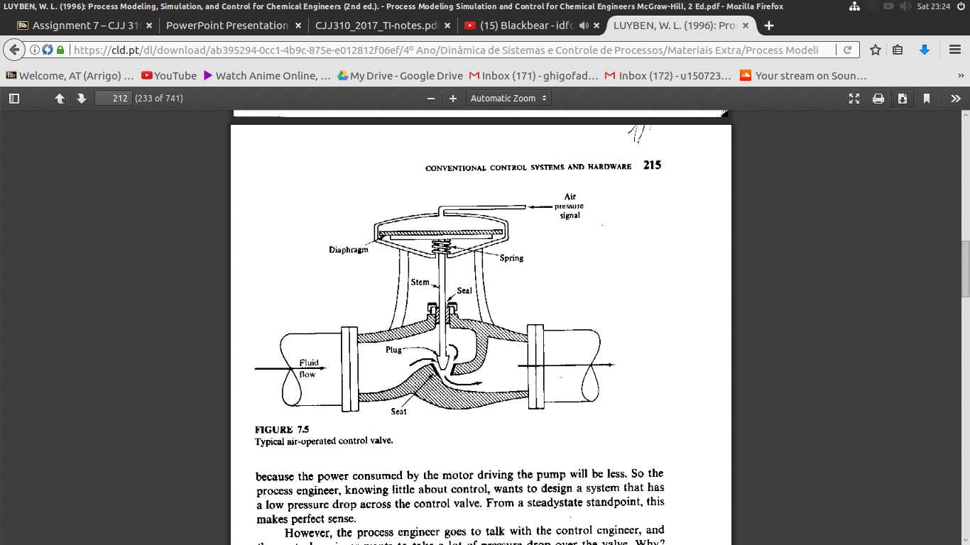

**Figure 1:** plug and stem design for control valve

For the control valve shown in Figure 1 the valve is closed when the plug is completely down and open when the plug is completely up. By controlling the position of the plug the flow rate is controlled.

The flow rate through a control valve depends on the size of the valve, the pressure drop over the valve, the stem position, and the fluid properties. (6. References)

The flow rate is given by

|  |  |  |
| --- | --- | --- |
|  | Screenshot from 2017-04-27 09-20-00 | () |

with *Q* the flow rate, *k* the valve size coefficient, *x* the valve opening, *ΔP* the pressure drop and *SG* the specific gravity (relative to water) of the fluid.

The pressure drop *ΔP i*s given by

|  |  |  |
| --- | --- | --- |
|  | Screenshot from 2017-04-27 09-22-11 | () |

with *h* the difference in height, ρ the density and *g* the acceleration due to gravity.

A typical configuration with a control valve is shown below in Figure 2

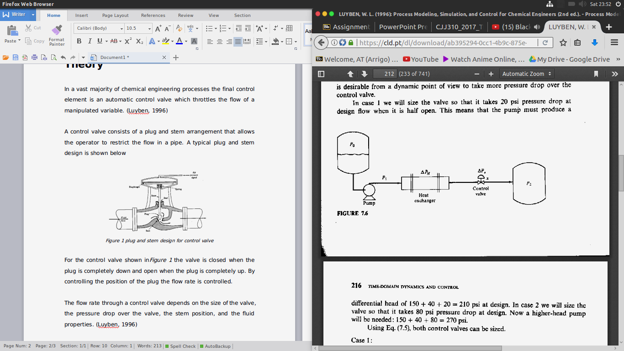

**Figure 2:** system involving control valve

# 3. Experimental

**Apparatus**

* Control valves to be categorized
* Water tank
* Level meter
* Flow meter
* Piping
* Pipe connectors

**Planning**

In order to categorise the control valves the experimental setup in Figure 3: experimental set up was configured with the goal of measuring the flow rates of a liquid as different value openings and from the experimental data calculating the valve size coefficient. Given the simplicity of the experiment PVC piping and water were used as the piping material and fluid to be analysed respectively. Pipe connectors were connected at the base of the tank as well as the connections between the valve and flow meter to prevent leakage.

**Method**

The experiment was set up as shown in Figure 3: experimental set up below

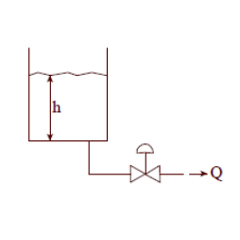

**Figure 3**: experimental set up

A hole at the base of the water tank was first drilled and a pipe connector was securely fitted to avoid leakage. The tank was then filled to a height of three meters with water at 4 °C and a simple level meter allowing for the height to be quickly measured was connected. Lastly the control valve to be tested and the flow meter were securely attached to the pipe.

The control valve was opened to a fraction of the total opening and the water was allowed to flow out while the height of the water in the tank as well as the flow rate of the water out of the control valve were measured and recorded.

The experiment was repeated for five different valve opening; experimental data was recorded and the flow rate was plotted against the square root of the pressure drop divided by the specific gravity. The slopes of these graphs were averaged and standard deviation was taken. The valve opening coefficient was then found by dividing the calculated slopes by the valve opening for the respective test. The average and standard deviation were then taken again.

# 4. Results and Discussion

**Table 1**: Linear flowrates experimentally determined with respect to fractional valve opening and height of water in the tank.

|  |  |  |  |  |  |
| --- | --- | --- | --- | --- | --- |
| **Height** | **x** | | | | |
| **0,1** | **0,4** | **0,5** | **0,6** | **0,7** |
| **Flowrate (m3h-1)** | **Flowrate (m3h-1)** | **Flowrate (m3h-1)** | **Flowrate (m3h-1)** | **Flowrate (m3h-1)** |
| **3** | 1,6 | 3,2 | 4,5 | 6,4 | 7,7 |
| **2,8** | 1,6 | 3 | 4,2 | 6,1 | 7,5 |
| **2,6** | 1,5 | 3,4 | 4,1 | 5,7 | 7,3 |
| **2,4** | 1,3 | 3,2 | 3,9 | 5,6 | 6,8 |
| **2,2** | 1,4 | 2,8 | 3,9 | 5 | 7 |
| **2** | 1,2 | 2,7 | 3,5 | 4,4 | 5,9 |
| **1,8** | 1,1 | 2,4 | 3,7 | 4,7 | 5,7 |
| **1,6** | 1,2 | 2,5 | 3,3 | 4,7 | 5,8 |
| **1,4** | 1 | 2,5 | 2,8 | 4 | 4,7 |
| **1,2** | 1 | 2 | 2,6 | 3,6 | 4,6 |
| **1** | 0,8 | 2 | 2,5 | 3,5 | 4,6 |
| **0,8** | 0,8 | 1,8 | 2,3 | 3 | 3,6 |
| **0,6** | 0,7 | 1,6 | 2 | 2,6 | 3,6 |
| **0,4** | 0,5 | 1,3 | 1,6 | 2,3 | 2,8 |
| **0,2** | 0,4 | 0,9 | 1,2 | 1,4 | 1,8 |
|  |  |  |  |  |  |

The experiment measured the flowrate through a valve at 5 different fractional valve openings. These openings were at 0.1, 0.4, 0.5, 0.6, 0.7.

**Table 2**: The square root of pressure calculated, and its value when multiplied by a respective fractional valve opening value.

|  |  |  |  |  |  |  |
| --- | --- | --- | --- | --- | --- | --- |
| **Pressure** |  | x | | | | |
| **Kpa** | **(Kpa SG-1)1/2** | 0,1 | 0,4 | 0,5 | 0,6 | 0,7 |
| 29,42 | 5,424 | 0,5424 | 2,17 | 2,712 | 3,254 | 3,797 |
| 27,456 | 5,242 | 0,5242 | 2,0960 | 2,620 | 3,144 | 3,668 |
| 25,5 | 5,05 | 0,5049 | 2,02 | 2,525 | 3,03 | 3,535 |
| 23,534 | 4,851 | 0,4851 | 1,941 | 2,426 | 2,911 | 3,396 |
| 21,58 | 4,645 | 0,465 | 1,858 | 2,322 | 2,787 | 3,251 |
| 19,61 | 4,429 | 0,4429 | 1,772 | 2,214 | 2,657 | 3,100 |
| 17,65 | 4,202 | 0,4201 | 1,681 | 2,101 | 2,521 | 2,941 |
| 15,69 | 3,961 | 0,3961 | 1,584 | 1,981 | 2,377 | 2,773 |
| 13,73 | 3,705 | 0,3705 | 1,482 | 1,853 | 2,223 | 2,594 |
| 11,77 | 3,431 | 0,3431 | 1,372 | 1,715 | 2,058 | 2,401 |
| 9,807 | 3,132 | 0,3132 | 1,253 | 1,566 | 1,879 | 2,192 |
| 7,846 | 2,801 | 0,2801 | 1,120 | 1,401 | 1,681 | 1,961 |
| 5,884 | 2,426 | 0,2426 | 0,9703 | 1,213 | 1,455 | 1,698 |
| 3,923 | 1,981 | 0,1981 | 0,7922 | 0,9903 | 1,188 | 1,386 |
| 1,961 | 1,400 | 0,1401 | 0,5602 | 0,7003 | 0,8403 | 0,9804 |

The flowrate was plotted with respect to the square root of the pressure difference across the valve. According to equation (1), a linear relationship was expected. This relationship was expected to produce a directly proportional straight line, when plotted. The gradient of this straight line represents the value of the flow coefficient. The value of the flow coefficient was expected to remain constant for each value of fractional valve opening and k, since it is kept constant and since k is constant. This value characterises the valve and should be the same as the fractional opening of the valve is changed. This implies that one should expect, generally, a parallel relationship in the graphs plotted.

**Figure 4:** The flowrate of the water flow out of the valve plotted with respect to the square root of the pressure drop across the valve.

From Figure 4**:** The flowrate of the water flow out of the valve plotted with respect to the square root of the pressure drop across the valve., the gradient of each graph plotted is generally the same (slight variance was expected.) From these graphs the flow coefficient is determined by getting each respective graph’s gradient.

**Table 3**: The slope of each graph in figure 1 and its respective k value. The variance in these values were also calculated.

|  |  |  |
| --- | --- | --- |
| x | Slope | k = Slope/x |
| 0,1 | 0,3035 | 3,032 |
| 0,4 | 0,5889 | 1,471 |
| 0,5 | 0,8184 | 1,636 |
| 0,6 | 1,179 | 1,965 |
| 0,7 | 1,4593 | 2,085 |
| avg | 0,8692 | 2,038 |
| std | 0,4599 | 0,6081 |
| std/avg | 0,5288 | 0,2984 |

The slope of each graph was divided to find the value of k. This value was expected to be the same for each value of fractional valve opening. Variance in this value was seen, as equation (1) represents an idealised case. The variance in these k values was minimal and suggested that an average k value can be used to characterise the valve.

To confirm this result, the flowrate with respect to fractional valve opening multiplied by the square root of the pressure difference across the valve was plotted. The slope of these gradients represents the value of k.

**Figure 5:** The flowrate with respect to fractional valve opening multiplied by the square root of the pressure difference across the valve

From Figure 5**:** The flowrate with respect to fractional valve opening multiplied by the square root of the pressure difference across the valve the graphs have a comparable gradient. This is in line with variance calculated. It was expected that k should not vary drastically.

From the data , one can conclude that since k does not vary drastically as the fractional valve opening is changed, an average can be used to characterise the valve. Thus the valve has a characterised k value of 0,8697.

# 5. Conclusion

In this report, a control valve given without specifications was analysed. The control valve was required to be characterised to be correctly implemented. The flowrate through this valve was measured experimentally, as water in a tank was let out at various fractional valve openings, specifically 0.1, 0.4, 0.5, 0.6 and 0.7.

The varying flow rates were plotted against the square-root of the change in pressure across the control valve divided by the specific gravity of liquid water, and the gradients were found. The flow coefficient, k, was calculated for each condition by dividing this gradient by the fractional opening used. There was minimum variance found between these k values, suggesting that using an average value would be best to characterise the valve. This average k value was found to be 0.8697 m3/hP1/2.

Therefore in conclusion, the given valve has a characterised k value of 0.8697 m3/hP1/2.

# 6. References

Luyben, WL (1996) P*rocess Modelling, Simulation and Control for Chemical Engineers.* 2nd ed, McGraw-Hill, Singapore.